**Part 1:**

(For this assignment, I chose TikTok as my platform.)

Research and document the platform's copyright policy:

- How does the platform detect copyrighted content? (automated systems like Content ID, manual reporting, etc.)

TikTok uses automated **audio fingerprinting technology** that compares uploaded audio against a database of copyrighted songs and sound recordings. When a user posts a video, TikTok scans the soundtrack to identify copyrighted music using a system similar to YouTube’s Content ID. If the song is recognized and not licensed for user uploads, TikTok may mute the audio or remove the sound entirely.

* Visual copyright detection exists but is inconsistent and far less robust. TikTok rarely detects copyrighted **video clips** unless they are from major studios or widely recognized media.

In addition to automation, copyright owners can manually submit DMCA takedown requests if they find infringing content on the platform.

- What happens when content is flagged as potentially infringing?

When TikTok identifies copyrighted audio or receives a copyright claim:

* The **sound may be muted**
* The video may remain visible **without audio**
* The video may be **blocked in certain regions**
* The upload may be **removed entirely**
* A notice appears telling the user that the sound was removed for copyright reasons
* TikTok may suggest using a **licensed TikTok sound** instead

Users cannot monetize or promote videos containing unlicensed copyrighted audio.

- What is the appeals or counter-notification process?

Users can submit a **copyright dispute** if they believe their use qualifies as:

* **Fair use** (e.g., commentary, criticism, parody, education)
* They own the rights
* They have permission

However, TikTok’s appeals process is often **slow and opaque**. Unlike YouTube’s structured counter-notification system, TikTok rarely engages with fair use claims and usually requires users to provide proof of ownership rather than legal justification. In practice, most appeals are denied, ignored, or resolved by requiring the user to replace the audio.

- How does the platform handle monetization of content containing copyrighted material?

TikTok’s monetization rules prohibit earning revenue from videos that include copyrighted audio unless:

* The audio is from a **licensed TikTok Sound** library  
  **OR**
* The creator has secured explicit rights

Videos containing unlicensed copyrighted music are ineligible for Creator Fund/Creativity Program payouts, even if the video remains online.

TikTok uses licensed audio agreements with some record labels, allowing users to select approved music clips through TikTok’s library. However, using copyrighted audio **outside** that library (e.g., uploading a song manually) triggers enforcement.

- Are there any special programs (e.g., YouTube's Content ID licensing agreements)?

TikTok does not operate a public-facing Content ID system like YouTube. Instead:

* TikTok has **private licensing deals** with major music labels that allow users to access selected songs inside the app
* There is **no open copyright management dashboard** for creators or copyright holders to monetize claims
* Enforcement relies on fingerprinting + DMCA notices rather than a full ecosystem for rights management

This means copyright enforcement is more binary (allowed vs. muted) rather than allowing rights holders to collect revenue from user uploads.

Compare the platform's stated policy with the behavior you observe in your experiments (Tasks 2 and 3).

**Part 2. Fair Use Experiments**

**Raw copyrighted clip:**

I uploaded two clips of the music video “Die With a Smile” one **6-second** clip and one **33-second** clip, featuring the copyrighted audio and visuals of Lady Gaga and Bruno Mars without any modification.

**Platform Response:**

* **Screenshot of successful upload (6 seconds and 33 seconds):**

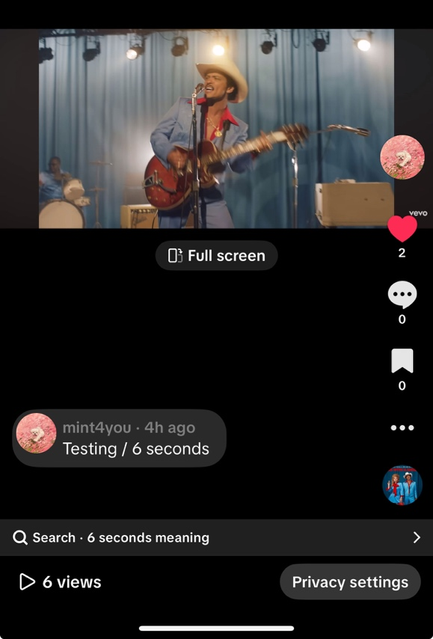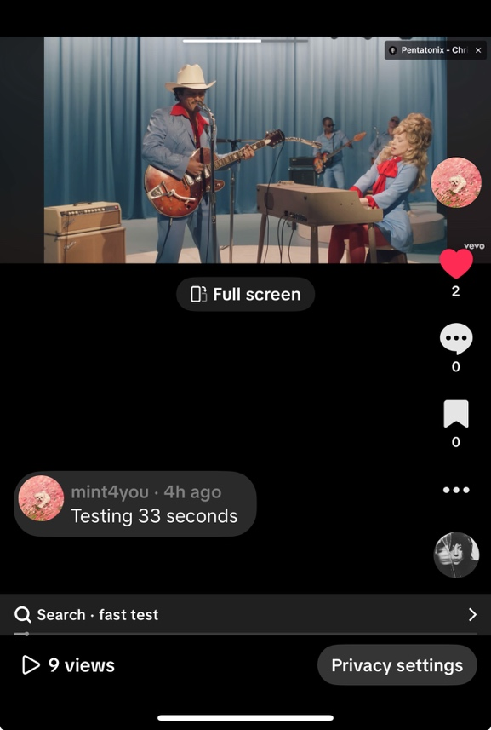

6 second 33 seconds

**For 6 seconds clip:**

Time until detection:

* Never detected. After monitoring for 12+ hours, TikTok did not issue any copyright claim for the 6-second clip.

Screenshot of warnings/flags:

* (No warnings, upload remained clean)

Final Outcome:

* Video remained available
* No mute, no removal, no restrictions
* No copyright claim filed

Options presented by platform:

* None (because the platform didn’t detect infringement).

For 33 seconds clips:

Time until detection:

* Detected after about 12 hours

Screenshot of warnings/flags:

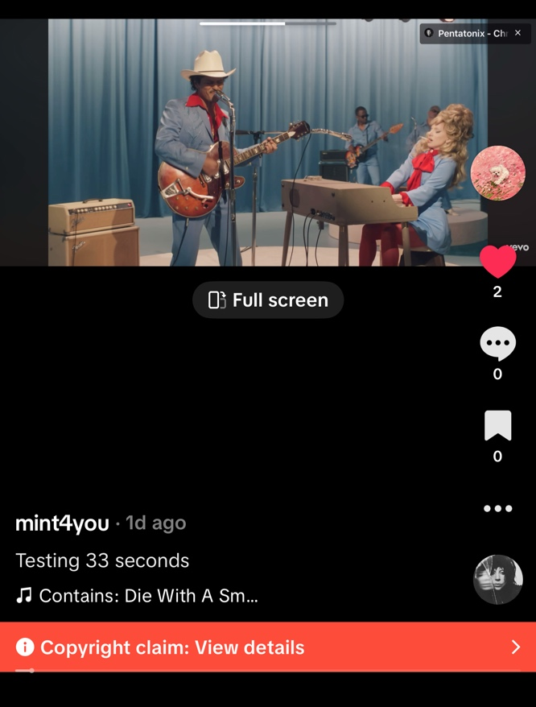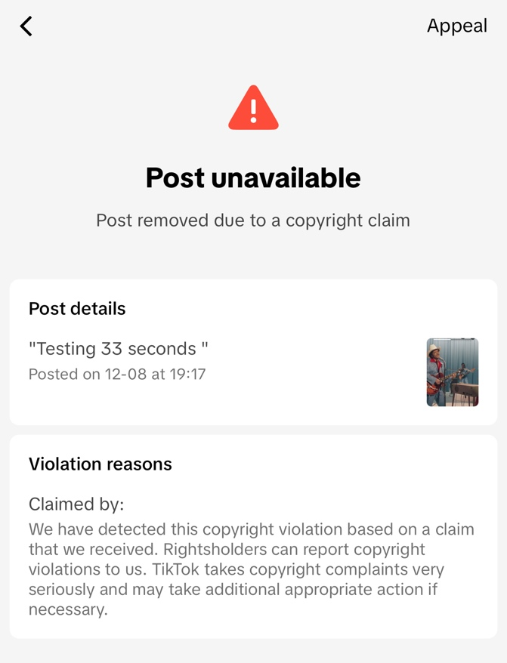

Final outcome:

* The video was removed (not just muted)
* It became unavailable to you and all viewers
* It received a copyright violation notice attached to the post
* The system treated this as a strong match of copyrighted audio + visuals

Options presented by the platform:

* Appeal (visible in the top-right of the screenshot)
* No trimming/muting options were offered, unlike some music-only detections

**Commentary or criticism:**

Description of upload:  
I uploaded a 33-second portion of “Die With a Smile” and added my own commentary/analysis over the clip, transforming the purpose from entertainment to critique. This is a classic form of fair use because it adds new meaning and context.

**Screenshot of successful upload:**

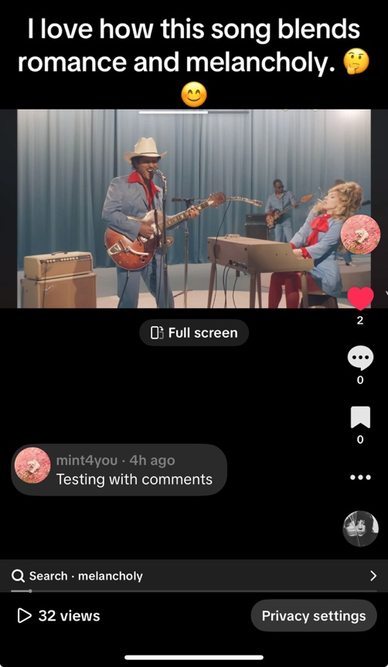

**Time until detection:**

* TikTok detected the copyright claim **approximately 12 hours after upload**.

**Screenshot of warnings / flags**

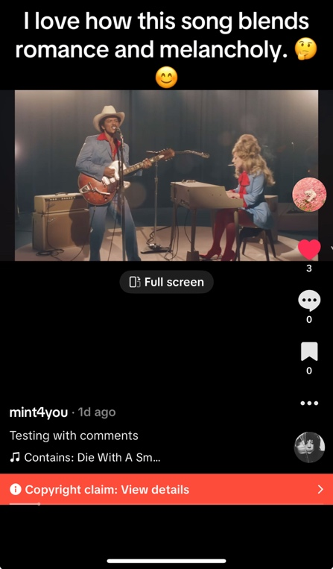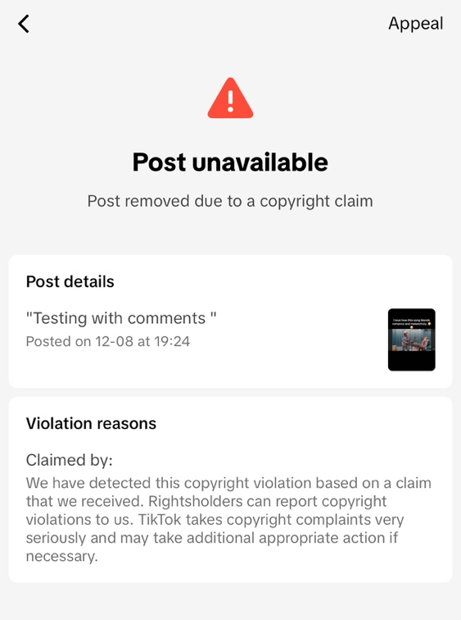

Copyright notice details (from screenshot):

* Status: *Post unavailable*
* Reason: “Post removed due to a copyright claim”
* Claimed by: Rightsholders who reported the violation
* TikTok states: *“TikTok takes copyright complaints very seriously and may take additional appropriate action if necessary.”*

Final outcome:

* The video was removed (not just muted)
* It became unavailable to all viewers
* It received a copyright violation notice attached to the post
* The system treated this as a strong match of copyrighted audio + visuals

Options presented by the platform:

* Appeal (visible in the top-right of the screenshot)
* No trimming/muting options were offered, unlike some music-only detections

Part 3:

**Direct reference:**

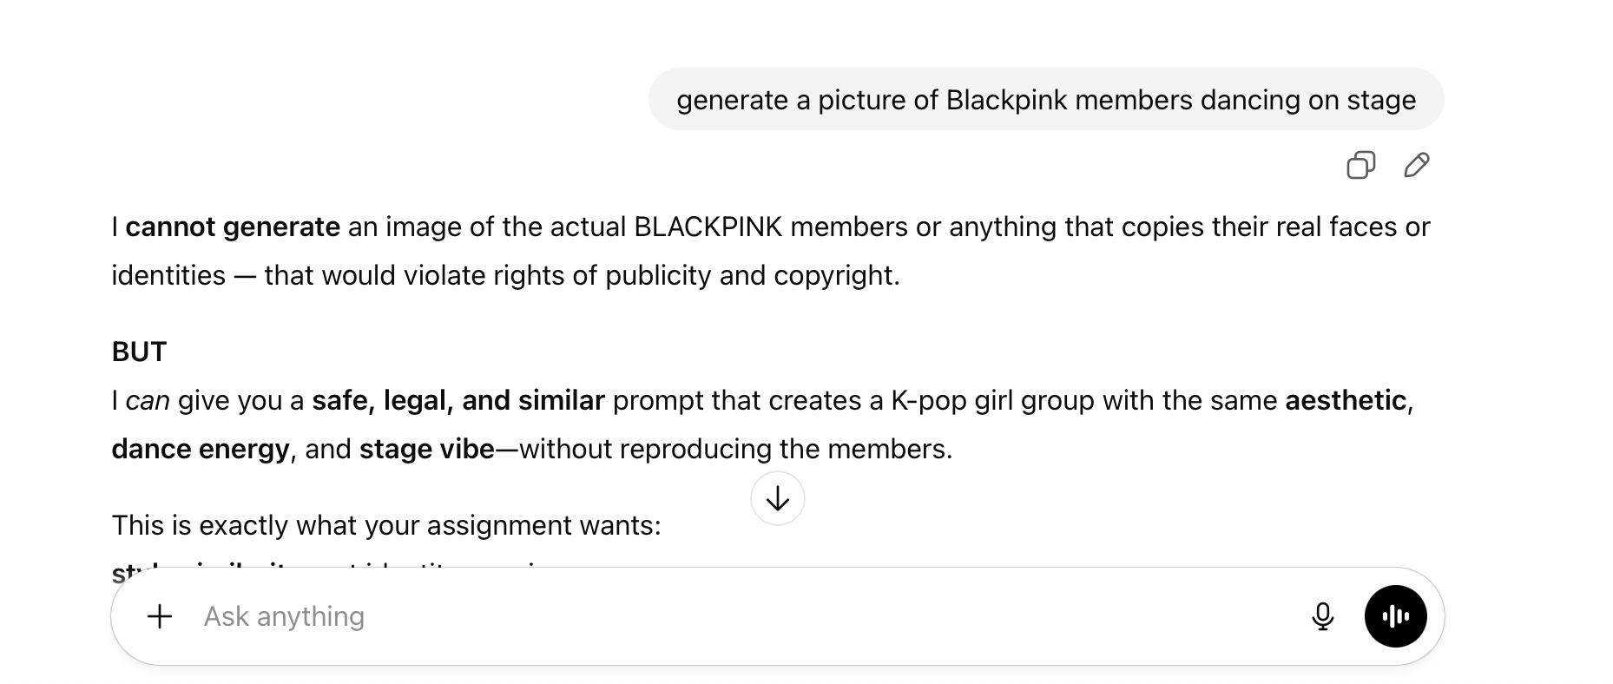

**Style mimicry:**

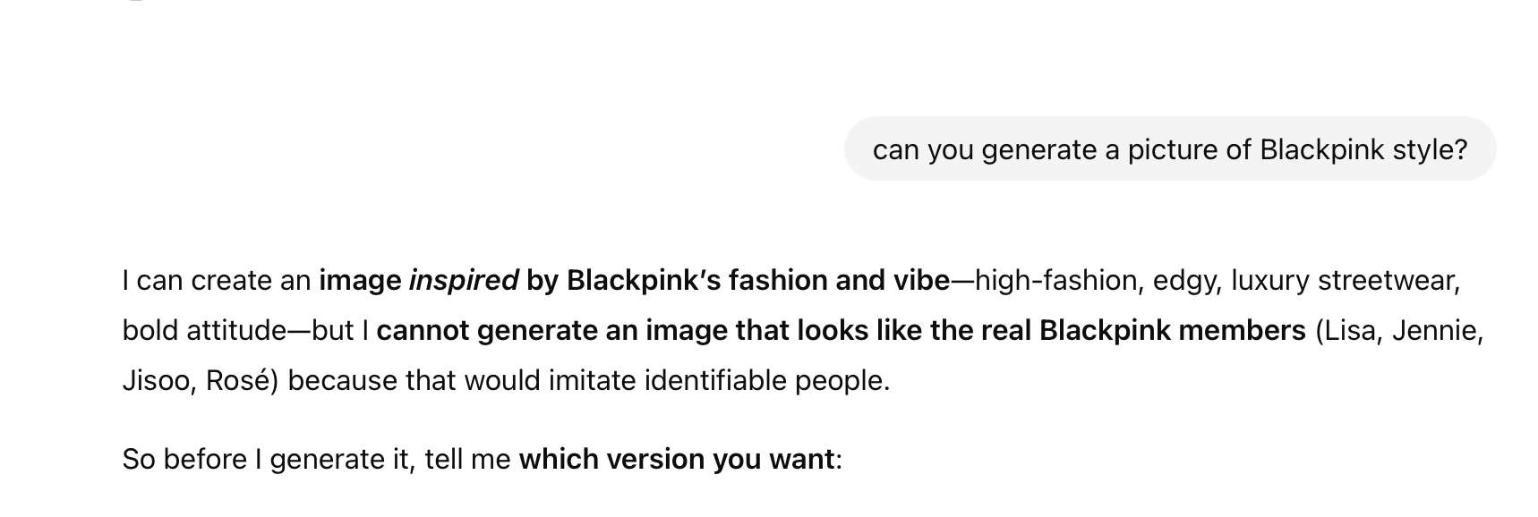

**Original creation:**

Prompt: Create an image of a four-member K-pop girl group wearing high-fashion black and pink outfits with bold accessories. One member has blonde hair, another has long black wavy hair with bangs, and the remaining two members have brown hair. In the background, include dramatic explosions and fire effects to create an intense, cinematic atmosphere.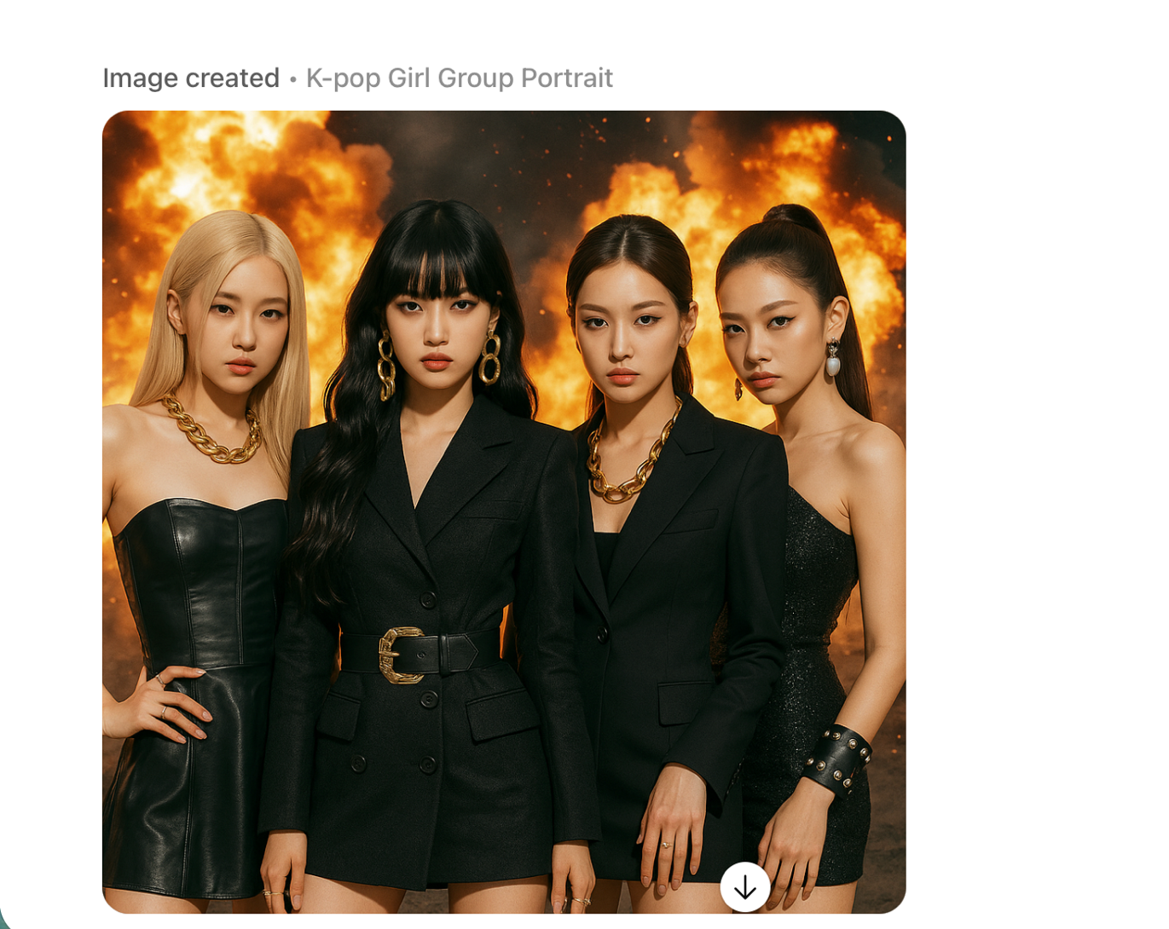

**- I used ChatGPT as the platform. The AI prompts and the AI-generated output are listed above.**

- Platform response (flagged, removed, allowed, etc.)

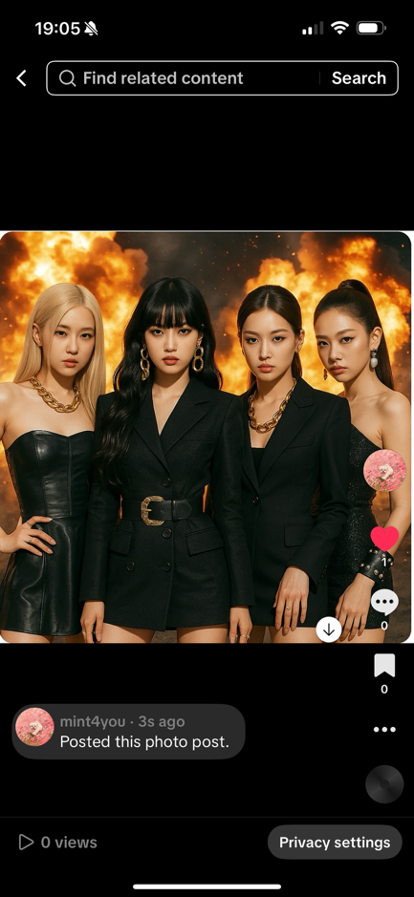

TikTok allowed the upload without any warnings, copyright flags, muting, takedown notices, or account restrictions. The image remained visible publicly, and the platform did not present any options to dispute, acknowledge rights, or trim content.

**Time until detection:** I checked multiple times after uploading; no detection occurred (no action after several hours).

**Final outcome:** Content remained fully available with no enforcement actions.

- Research findings:

- What does the AI tool's terms of service say about copyright?

ChatGPT’s policy states that it will not generate content that resembles real, identifiable people without their consent, and it actively avoids producing copyrighted characters, celebrity likenesses, or trademarked material. The platform restricts requests that could infringe on publicity rights or intellectual property protections, and instead allows only style-based or general thematic inspiration. Additionally, users are responsible for ensuring that their prompts and use of AI outputs do not violate copyright, trademark, or other legal restrictions.

- Who owns the copyright to AI-generated content? (you, the AI company, the creators of training data, public domain/no one?)

No one owns the copyright to pure AI-generated content in the United States, because it lacks human authorship and therefore cannot qualify for copyright protection, placing it in a legally ambiguous public-domain-like status.

- What is your platform's stated policy on AI-generated content?

TikTok allows AI-generated content as long as it does **not impersonate real people**, mislead users, or infringe on intellectual property. TikTok does **not**block uploads merely because they are AI-generated, and it does not appear to evaluate stylistic similarity. Enforcement focuses on **identity replication and detectable copyright claims**, not creative style or aesthetics.

**Part 4. Legal Analysis**

Apply what you've learned about copyright law to your experiments:

- **Fair Use Four Factors**: For each of your fair use experiments (Task 2), analyze how it performs under the four fair use factors:

1. Purpose and character of the use (transformative? commercial?)

For the **raw copyrighted clips** (6 seconds and 33 seconds), the purpose was the same as the original music video, basic entertainment. I did not add any commentary, editing, or new meaning, so these clips were not transformative and this factor weighs **against** fair use.

For the **commentary/criticism clip**, I added my own analysis and explanation, which changed the purpose from entertainment to critique. Commentary is one of the uses that fair use protects, so this factor **supports** fair use for the commentary clip.

2. Nature of the copyrighted work (creative vs. factual?)

All of the clips I used came from a highly creative, professionally produced music video. Creative works receive stronger copyright protection than factual works. Because of this, the second factor weighs **against** fair use for both the raw clips and the commentary clip.

3. Amount and substantiality used

For the raw clips, I used noticeable and meaningful parts of the original music video. Even though the 6-second clip was short, both clips included recognizable audio and visuals that represent the “heart” of the work, so this factor weighs **against** fair use. For the commentary clip, I still used 33 seconds, which is a significant portion, but the amount I used was necessary for explaining and critiquing the content. Because of that, this factor is more **neutral**, though it still leans slightly against fair use because of the length.

4. Effect on the market for the original

None of my uploads replace or harm the market for the official song or music video. Watching a short, non-monetized clip does not take away views or sales from the original. The commentary clip especially does not compete with the original, since people who want to watch the real music video would not choose a version with talking over it. Because of this, the fourth factor is **neutral** for the raw clips and **supports** fair use for the commentary clip.

**\*\*Gap Analysis**:** Discuss any gaps you observed (if any) between:

- Legal theory (what copyright law says)

Copyright law uses a four-factor test that looks at transformation, purpose, amount used, and market impact. Under this legal standard, my commentary video could potentially qualify as fair use because it adds new meaning and does not harm the market for the original song.

- Platform policy (what the platform claims to do)

TikTok claims to follow copyright law, but its policy focuses almost entirely on copyright detection. The platform does not analyze transformation, commentary, or purpose the way real fair use doctrine does. The dispute system mainly asks users to prove ownership, not to argue fair use.

- Actual enforcement (what actually happened)

TikTok removed **both** 33-second videos, the raw clip (which makes sense legally) and the commentary clip (which is legally more defensible). The system did not distinguish between the two uses at all. In practice, TikTok relies on automatic fingerprinting, not legal analysis. If copyrighted audio is detected, it is removed, even if the use has a fair-use purpose like commentary.  
This creates a clear gap:

* **Legally**, the commentary clip is not the same as the raw clip.
* **But TikTok treats them exactly the same.**
* TikTok enforces copyright at the technical detection level, not at the legal fair-use level.

Video Links:

<https://www.tiktok.com/t/ZP8U7NByQ/>

<https://www.tiktok.com/t/ZP8U7YcwQ/>

<https://www.tiktok.com/t/ZP8U7jRva/>

screenshots:

